A ONE-MONTH COURSE FOR CLASS XII
THE WORLD OF
GENERATIVE AI

Sub-topic: Understanding Large Language Models (LLMs)
Student Study Material • Simple Language • Diagrams • Activities • Quizzes
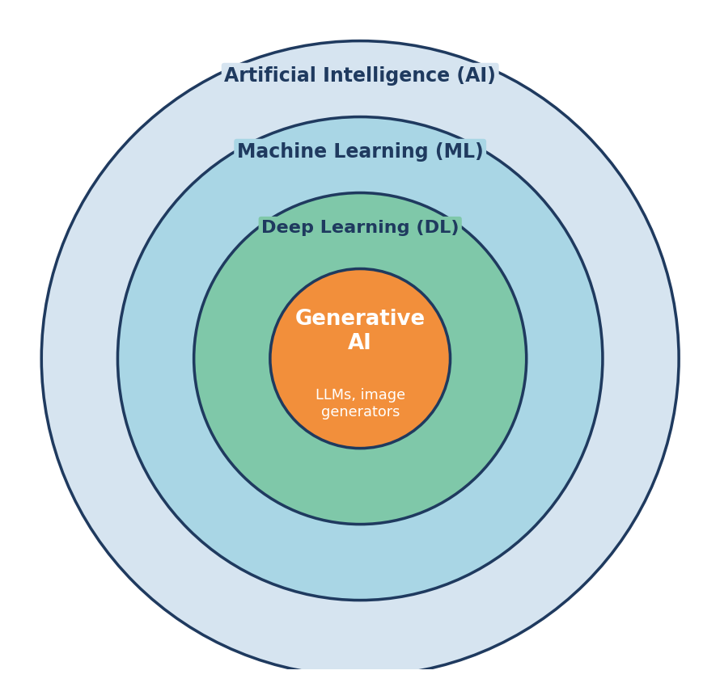
Generative AI sits inside Deep Learning, Machine Learning and Artificial Intelligence.
Name: ______________________ Class: ________ Roll No.: ________

About This Course
Welcome! In the last few years, computers have learned to write essays, answer questions, draw pictures, compose music and even write programs. All of this is called Generative AI. You may already use tools such as chatbots every day. But do you know how they work? This course will open the “black box” and explain the ideas behind it in simple language.
The main focus of the course is Large Language Models (LLMs) — the technology behind modern AI chatbots. You do not need advanced mathematics or programming to follow this book. If you can understand ideas such as “prediction”, “pattern” and “probability”, you are ready.

Who is this course for?
- Students of Class 12 (any stream — Science, Commerce or Arts).
- Learners who are curious about Artificial Intelligence and want to use it wisely.
- Students who plan to study computer science, data science, engineering, medicine, business, design or any other field in the future.

Course at a glance
Item | Details
Duration | One month (4 weeks)
Sessions | 20 sessions of about 60–90 minutes (5 per week) + weekly revision
Study material | This book — 13 chapters
Method | Reading, diagrams, discussions, activities, quizzes, a mini project
Assessment | Weekly quiz, activity record, final project and viva
Prior knowledge | Basic computer and internet use only

Course Roadmap
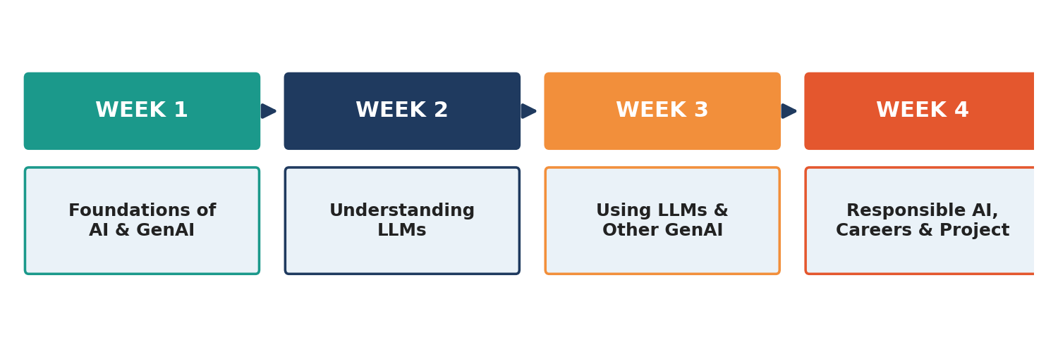
The four weeks of the course.

What you will be able to do at the end
- Explain the difference between AI, Machine Learning, Deep Learning and Generative AI.
- Describe in simple words what a Large Language Model is and how it is built.
- Explain tokens, embeddings, the Transformer and the attention idea using diagrams.
- Describe how an LLM is trained — pre-training, fine-tuning and human feedback.
- Write clear and effective prompts to get better answers from AI tools.
- Identify the limits of AI, such as hallucination and bias, and check facts carefully.
- Understand how image, audio and video generators work at a basic level.
- Use AI in a safe, honest and responsible way.

How to use this book
- Read the Learning Objectives at the start of each chapter.
- Study the diagrams carefully. A picture often explains more than a paragraph.
- Do the Activities — they are the best way to learn.
- Answer the Check Your Understanding questions without looking at the text first.
- Keep a notebook for new words. A Glossary is given at the end.

One-Month Teaching Plan
The table below shows how the 13 chapters can be covered in 20 sessions. A teacher may adjust the pace according to the class.
Week | Session | Topic | Chapter
1 | 1 | What is Generative AI? AI, ML, DL | 1
1 | 2 | History and examples of Generative AI | 1
1 | 3 | How machines learn — types of learning | 2
1 | 4 | Neural networks | 2
1 | 5 | Revision + Quiz 1 | 1–2
2 | 6 | What is an LLM? Why “large”? | 3
2 | 7 | Tokens and embeddings | 4
2 | 8 | Transformer and attention | 5
2 | 9 | Training an LLM | 6
2 | 10 | Revision + Quiz 2 | 3–6
3 | 11 | How an LLM writes — next-word prediction | 7
3 | 12 | Prompt engineering (Part 1) | 8
3 | 13 | Prompt engineering (Part 2) — practice | 8
3 | 14 | Limits: hallucination, bias, RAG | 9
3 | 15 | Images, audio, video generation + Quiz 3 | 10
4 | 16 | Ethics, safety and privacy | 11
4 | 17 | Applications and careers | 12
4 | 18 | Project work | 13
4 | 19 | Project presentations | 13
4 | 20 | Final test and viva | All

Contents
Ch. | Title | Week
1 | The World of Generative AI — An Introduction | 1
2 | How Machines Learn | 1
3 | Understanding LLMs — What Is a Large Language Model? | 2
4 | From Words to Numbers — Tokens and Embeddings | 2
5 | The Transformer and the Power of Attention | 2
6 | How an LLM Is Trained | 2
7 | How an LLM Writes — Generating Text | 3
8 | Talking to AI — The Art of Prompting | 3
9 | Limits and Risks of LLMs | 3
10 | Beyond Text — Images, Audio and Video | 3
11 | Using AI Responsibly — Ethics and Safety | 4
12 | Applications, Careers and the Future | 4
13 | Mini Project, Revision Quiz and Glossary | 4

Chapter 1
The World of Generative AI — An Introduction
Week 1 • Sessions 1–2
🎯 Learning Objectives
After this chapter, you will be able to:
• Define Artificial Intelligence, Machine Learning, Deep Learning and Generative AI.
• Explain how Generative AI is different from other kinds of AI.
• Name examples of Generative AI in daily life.
• Describe the important events in the history of AI.

1.1 A Quick Look at the Generative AI World
Imagine you type: “Write a short poem about monsoon rain in Tamil Nadu.” In a few seconds a computer writes a poem that has never been written before. Imagine you describe a picture — “a blue elephant flying over a school” — and the computer draws it. This ability to create new content is what we call Generative AI.
The word generate means to create or to produce. So Generative AI is a type of Artificial Intelligence that can create new content such as text, images, audio, video, music and computer code. It does not simply copy an existing item. It learns patterns from a huge amount of examples and then produces something new that follows those patterns.
📌 Example
Think of a student who has read thousands of stories. If you ask the student to write a new story, she does not copy one story. She uses the style, words and ideas she has learned. Generative AI works in a similar way — but it has “read” far more than any human can.

1.2 AI, Machine Learning, Deep Learning and Generative AI
These four terms are often mixed up. The best way to understand them is as circles inside circles, as shown in Figure 1.1.
Figure 1.1: AI is the biggest idea. Each inner circle is a more specialised part of the one outside it.
Term | Simple meaning | Example
Artificial Intelligence (AI) | Making machines do tasks that normally need human intelligence. | A chess program, a voice assistant, a route planner
Machine Learning (ML) | A part of AI where computers learn patterns from data instead of being given fixed rules. | Email spam filter, movie recommendations
Deep Learning (DL) | A part of ML that uses many-layered “neural networks”. Good with images, sound and language. | Face unlock, speech-to-text
Generative AI (GenAI) | A part of deep learning that creates new content. | A chatbot writing an essay; an app drawing a picture

1.3 Predictive AI vs Generative AI
Earlier AI systems were mostly predictive or discriminative. They looked at an input and chose a label or a number. Generative AI does something different: it produces a new output.
Feature | Predictive / Discriminative AI | Generative AI
Main job | Classify, predict or detect | Create new content
Typical output | A label or number (e.g., “spam” / “not spam”) | Text, image, audio, video, code
Example question | “Is this photo a cat or a dog?” | “Draw a cat wearing a school uniform.”
Training data needed | Often labelled examples | Very large collections of text, images, etc.
Example | Fraud detection in banking | Chatbots, image generators

1.4 What Can Generative AI Create?
Type of content | What it can do | Everyday example
Text | Write, summarise, translate, answer questions | Chatbot explaining a science topic
Images | Create pictures from a written description | Poster or logo ideas
Audio & music | Generate speech, voices and tunes | Reading a lesson aloud
Video | Create short clips from text | Animated explainer
Code | Write and fix computer programs | Suggesting code in a coding tool
3D & design | Make shapes, layouts and designs | Product design drafts

1.5 A Short History
Generative AI looks new, but its roots go back more than seventy years. Figure 1.2 shows some important milestones.
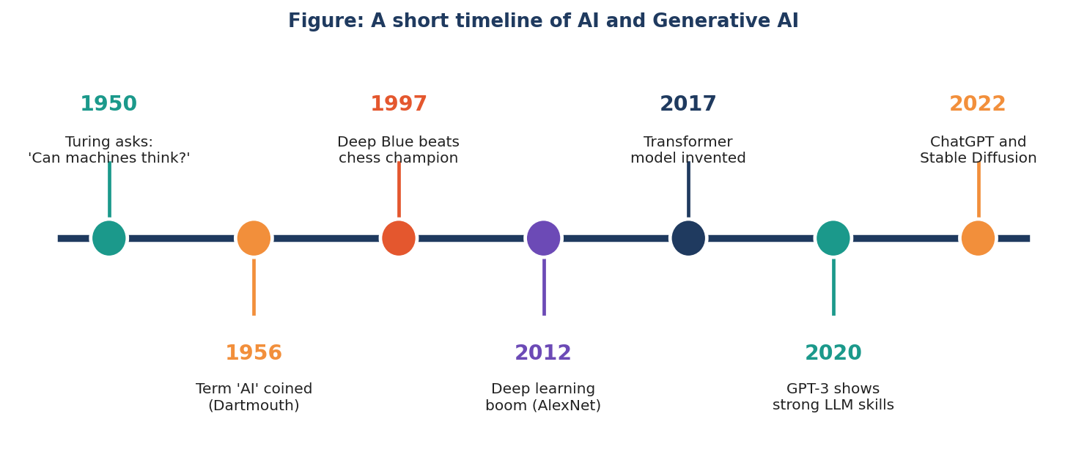
Figure 1.2: Milestones in the history of AI.
- 1950 — Alan Turing asked, “Can machines think?” and proposed a test for machine intelligence.
- 1956 — At a workshop at Dartmouth College (USA), the term “Artificial Intelligence” was introduced.
- 1997 — IBM’s Deep Blue computer defeated world chess champion Garry Kasparov.
- 2012 — Deep learning became very popular after a neural network won a major image-recognition contest.
- 2014 — Generative Adversarial Networks (GANs) were introduced for creating images.
- 2017 — Researchers at Google introduced the Transformer, the design behind today’s LLMs.
- 2020 — GPT-3, a very large language model, showed surprisingly good writing ability.
- 2022 — ChatGPT and image generators such as Stable Diffusion brought Generative AI to millions of people.
💡 Did You Know?
Between 2017 and 2022 — only five years — language AI went from a research idea to a tool used by hundreds of millions of people. Very few technologies have spread so fast.

1.6 Generative AI Around You
You may already be using Generative AI without noticing it:
- Chat assistants that answer homework or general-knowledge questions.
- Keyboard suggestions that complete your sentences.
- Apps that translate languages instantly.
- Tools that remove the background from a photo or make a photo sharper.
- Study apps that explain a lesson step by step.
- Programming tools that suggest the next line of code.
⭐ Key Points to Remember
Generative AI is AI that creates new content — text, images, audio, video or code.
AI ⊃ Machine Learning ⊃ Deep Learning ⊃ Generative AI.
Predictive AI chooses labels or numbers; Generative AI makes new things.
The Transformer (2017) made modern Large Language Models possible.

✏️ Activity: My AI Diary
For one day, write down every place where you meet AI (phone, TV, apps, shops, banks).
Mark which ones are predictive (they decide or recommend) and which are generative (they create).
Share your list with a classmate and compare.

❓ Check Your Understanding
1. Define Generative AI in your own words.
2. Draw the diagram showing AI, ML, DL and GenAI. Label each circle.
3. Give two differences between predictive AI and Generative AI.
4. Which invention in 2017 made today’s language models possible?
5. Name three types of content that Generative AI can create.

Chapter 2
How Machines Learn
Week 1 • Sessions 3–5
🎯 Learning Objectives
After this chapter, you will be able to:
• Explain the difference between traditional programming and machine learning.
• Name and describe the three main types of machine learning.
• Describe a neural network and its layers.
• Explain in simple terms how a model is “trained”.

2.1 Two Ways to Teach a Computer
In traditional programming, a human writes exact rules: “If the marks are above 90, give grade A.” The computer follows the rules and gives answers.
But some problems are too difficult for rules. How would you write rules to recognise a cat in a photo, or to understand a joke? There are too many cases. In machine learning we do the opposite: we give the computer many examples (data) and the correct answers, and the computer finds the rules by itself.
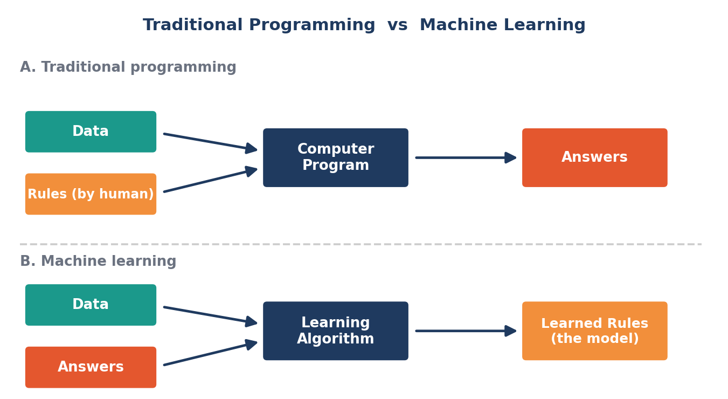
Figure 2.1: In machine learning, the computer discovers the rules from examples.
📌 Example
Learning to ride a bicycle. Nobody gives you a book of rules about balance. You try, you fall, you adjust — and slowly your brain learns the pattern. Machine learning is also learning from experience.

2.2 Types of Machine Learning
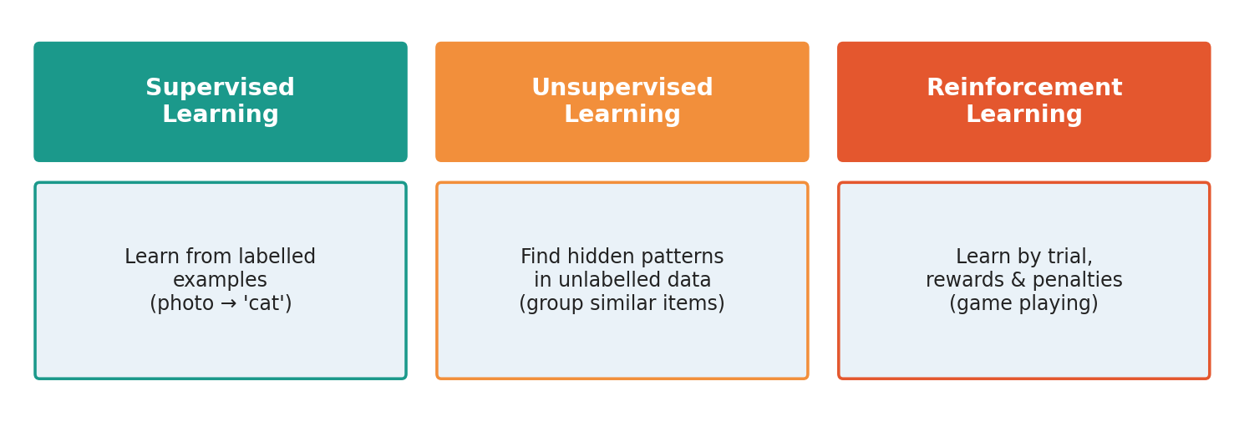
Figure 2.2: Three main ways in which machines learn.

Supervised learning
The computer is given examples with labels — for instance, thousands of photos marked “cat” or “dog”. It learns to match pictures to labels. It is like learning with a teacher who tells you the right answer.

Unsupervised learning
The data has no labels. The computer searches for hidden patterns by itself, such as grouping customers who buy similar things. It is like sorting a box of mixed buttons by colour and size without being told how.

Reinforcement learning
The computer learns by trial and error. It gets a reward for good actions and a penalty for bad ones — like a game player trying to get the highest score. A special version of this is also used to improve chatbots (see Chapter 6).
📌 Example
Self-supervised learning is the idea most important for LLMs. Here the data creates its own labels. For example, from the sentence “The sun rises in the east”, we hide the last word and ask the model to guess it. The correct answer (“east”) is already in the sentence, so no human has to label anything. This lets us train on enormous amounts of text.

2.3 Neural Networks — The Brain-Inspired Model
A neural network is a computer model loosely inspired by the human brain. It is made of many small units called neurons (or nodes) arranged in layers.
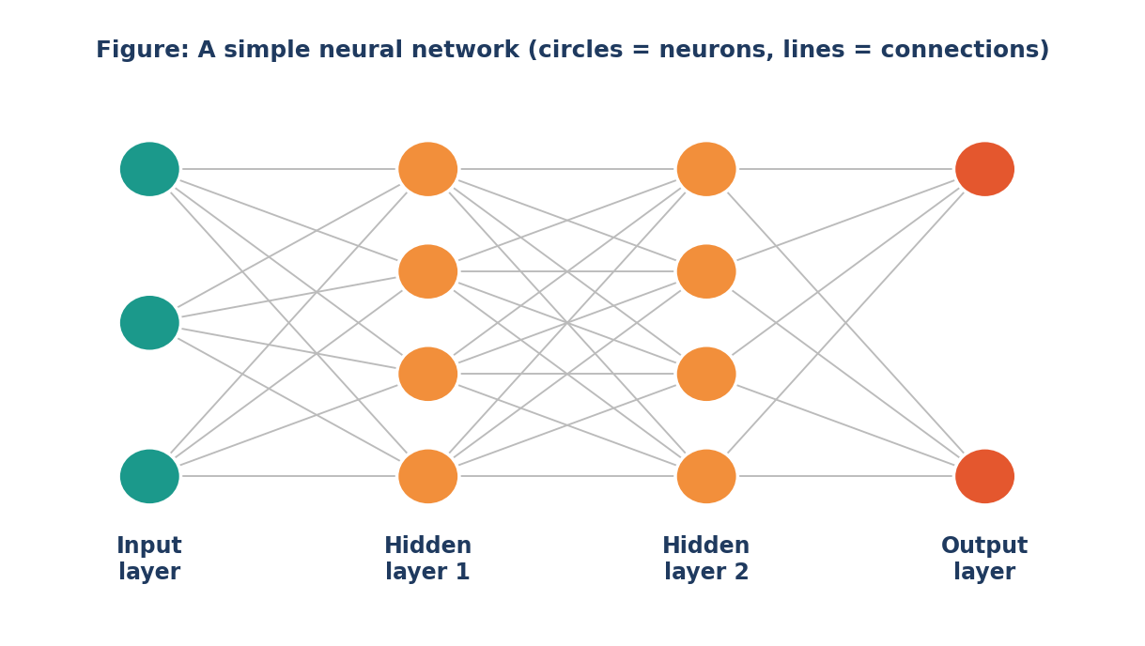
Figure 2.3: A neural network with an input layer, two hidden layers and an output layer.
- Input layer — receives the data (for example, the pixels of a picture or the tokens of a sentence).
- Hidden layers — do the “thinking”. Each layer finds more complex patterns than the one before it.
- Output layer — gives the final result (a label, a number or the next word).
- Weights — numbers on the connections. They decide how strongly one neuron influences the next. Learning means adjusting the weights.
Deep learning simply means using neural networks with many hidden layers (that is why it is called deep). Modern LLMs have dozens of layers and billions of weights.

2.4 How Training Works — Step by Step
- Start with random weights. At first the model knows nothing and its answers are poor.
- Show an example and let the model make a guess.
- Measure the error. Compare the guess with the correct answer. The difference is called the loss.
- Adjust the weights slightly so that the next guess is a little better. (The method used is called backpropagation with gradient descent.)
- Repeat millions or billions of times with new examples until the error becomes small.
📌 Example
Guess the number game. A friend thinks of a number between 1 and 100. You guess 50 — “too low”. You guess 75 — “too high”. Each hint helps you improve. Training a model is like playing this game billions of times, with the model improving after every hint.

2.5 Important Words
Word | Meaning
Data | The examples used to teach the model (text, pictures, sound...)
Model | The learned “brain” — the neural network with its final weights
Parameters / weights | The numbers inside the model that are adjusted during learning
Training | The process of adjusting the weights using data
Inference | Using the trained model to give answers (what happens when you chat with it)
Algorithm | A set of steps used to solve a problem or to learn

⭐ Key Points to Remember
Machine learning = learning rules from data, not writing rules by hand.
Three types: supervised, unsupervised and reinforcement learning.
LLMs mainly use self-supervised learning — predicting hidden words.
A neural network learns by repeatedly adjusting its weights to reduce error.

✏️ Activity: Human Neural Network
Form a line of 3 groups: Input group, Hidden group and Output group.
Give the input group a sentence with one missing word. The message is whispered to the hidden group, which discusses it and passes a guess to the output group.
The output group says the final word. Discuss: which ‘neurons’ gave the best help? This is similar to adjusting weights.

❓ Check Your Understanding
1. What is the main difference between traditional programming and machine learning?
2. Match: supervised / unsupervised / reinforcement with (a) rewards and penalties (b) labelled data (c) finding hidden groups.
3. What are weights and why are they important?
4. What is the difference between training and inference?
5. Why is it called “deep” learning?

Chapter 3
Understanding LLMs — What Is a Large Language Model?
Week 2 • Session 6
🎯 Learning Objectives
After this chapter, you will be able to:
• Define a Large Language Model in simple words.
• Explain why these models are called “large”.
• Describe what an LLM can and cannot do.
• Understand the idea that an LLM works by predicting the next piece of text.

3.1 What Is a Language Model?
A language model is a computer program that has learned how human language works — which words usually come together, how sentences are built, and what ideas usually follow other ideas.
You already use a tiny language model on your phone. When you type “Good”, the keyboard suggests “morning”, “evening” or “luck”. It is predicting the next word. A Large Language Model (LLM) does the same thing, but on a gigantic scale — with a far bigger “brain” and far more reading.
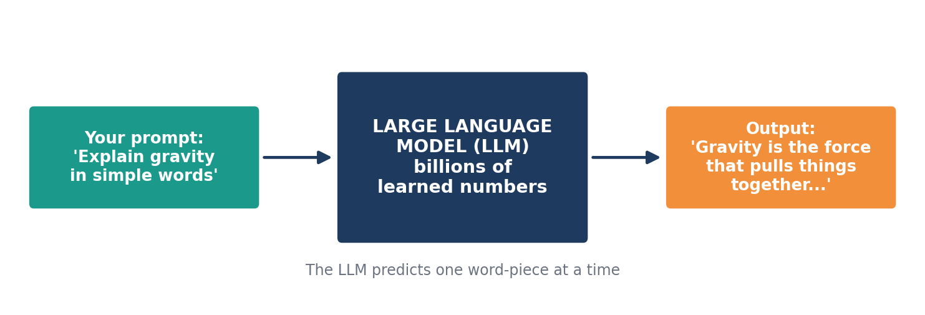
Figure 3.1: An LLM takes text as input and produces text as output.
📖 Definition
A Large Language Model (LLM) is a very large neural network, trained on huge amounts of text, that can understand and generate human-like language by predicting what text should come next.

3.2 Why Do We Say “Large”?
“Large” refers to three things at once:
What is large? | Meaning | Simple comparison
Data | Trained on books, articles, websites, programming code and more — billions of words. | More text than a person could read in thousands of lifetimes.
Model size (parameters) | The number of adjustable numbers (weights) inside the model — often billions or more. | Like the number of tiny dials in a giant control room.
Computing power | Trained on thousands of powerful computer chips running for weeks or months. | Like a huge factory working day and night.

Researchers found that as models become larger and are trained on more data, they suddenly become better at many tasks — translating, summarising, answering questions and writing code — even tasks they were not specially taught. Figure 3.2 shows how quickly model sizes grew in the early GPT family.
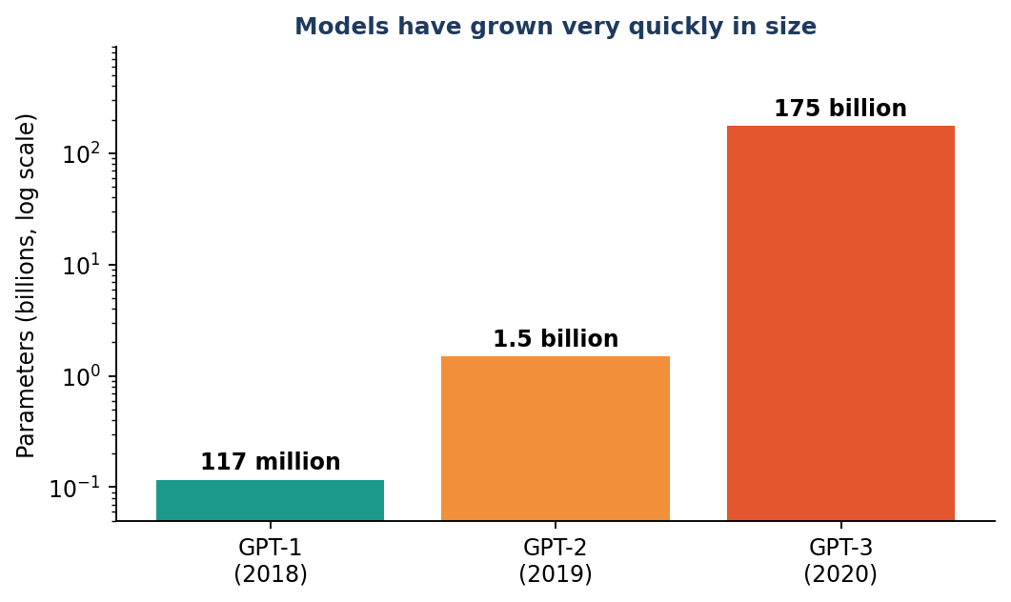
Figure 3.2: The number of parameters grew from millions to billions in just two years (log scale).
💡 Did You Know?
A parameter is one adjustable number inside the model. A model with 175 billion parameters has 175,000,000,000 such numbers! Together they store everything the model has learned about language.

3.3 What Can an LLM Do?
Skill | Example request
Answering questions | “Why is the sky blue?”
Summarising | “Summarise this chapter in 5 lines.”
Translating | “Translate this paragraph into Tamil.”
Writing | “Write a leave letter to my principal.”
Explaining | “Explain photosynthesis like I am 10 years old.”
Coding | “Write a Python program to find prime numbers.”
Brainstorming | “Give me 10 ideas for a science exhibition.”
Reasoning with steps | “Solve this word problem and show the steps.”

3.4 Is an LLM Really “Thinking”?
This is an important question. An LLM is not a human brain and does not have feelings, personal experiences or true understanding in the way people do. Inside, it is doing a huge amount of mathematics on numbers to calculate which text is most likely to come next.
Yet because it has learned from so much human writing, its output often looks intelligent. Scientists still debate how much “understanding” these models have. As a student, remember the safe view: an LLM is a powerful pattern-learning tool, not an all-knowing person.
🧠 Think about it
A parrot can repeat words but may not understand them. An LLM is far more advanced than a parrot — but it can still sound confident even when it is wrong. That is why we must always check important facts.

3.5 The Big Idea in One Sentence
Everything an LLM does comes from one simple skill, repeated again and again:
🔑 Core idea
Given the text so far, predict the next token (a word or a piece of a word).

To answer “What is the capital of France?”, the model predicts “The”, then “capital”, then “of”, then “France”, then “is”, then “Paris” — one piece at a time. In the next chapters we will learn how text becomes numbers, how the model pays attention to the right words, and how it is trained to predict well.

3.6 Families of Language Models
Many companies and research groups build LLMs. Some are closed (used only through a website or app), and others are open-weight (their weights are shared so developers can run and study them). Models also come in different sizes: small models can run on a laptop or a phone, while very large models need big data centres. In general, bigger models are more capable but cost more to run.
Type | Features | Good for
Small models | Fast, cheap, can run on your own device | Simple tasks, privacy, offline use
Large models | More knowledge and better reasoning, need data centres | Complex writing, coding, analysis
Open-weight models | Weights can be downloaded and studied | Research, learning, custom apps
Multimodal models | Understand text, images, audio together | Describing pictures, reading charts

⭐ Key Points to Remember
An LLM is a very large neural network trained on huge amounts of text.
“Large” means large data, large number of parameters and large computing power.
Its core skill is predicting the next token.
LLMs are powerful tools but they are not human and can make mistakes.

✏️ Activity: Be the Keyboard
Write the start of a sentence, e.g., “My favourite subject is ...”.
Ask five classmates to complete it with one word. Count the answers.
Which word is the most common? You have just seen probability — the same idea LLMs use for next-word prediction.

❓ Check Your Understanding
1. What is a Large Language Model?
2. Give three meanings of the word “large” in LLM.
3. What is a parameter?
4. Why should we not think of an LLM as a person who truly understands everything?
5. What is the one basic skill from which all LLM abilities come?

Chapter 4
From Words to Numbers — Tokens and Embeddings
Week 2 • Session 7
🎯 Learning Objectives
After this chapter, you will be able to:
• Explain why text must be converted into numbers.
• Describe what a token is and how tokenization works.
• Explain word embeddings using the idea of a “meaning map”.
• Understand why similar words have similar numbers.

4.1 Computers Understand Only Numbers
A computer cannot read letters or words in the way we do. Inside, everything is a number. So before an LLM can work with text, the text must be changed into numbers in two steps:
- Tokenization — break the text into small pieces called tokens and give each piece an ID number.
- Embedding — turn each ID number into a long list of numbers that captures the meaning of that token.

4.2 Tokens and Tokenization
A token is a small piece of text. It may be a whole word (“school”), part of a word (“Gener” + “ative”), a punctuation mark (“!”) or even a space plus a word. The program that does this splitting is called a tokenizer.
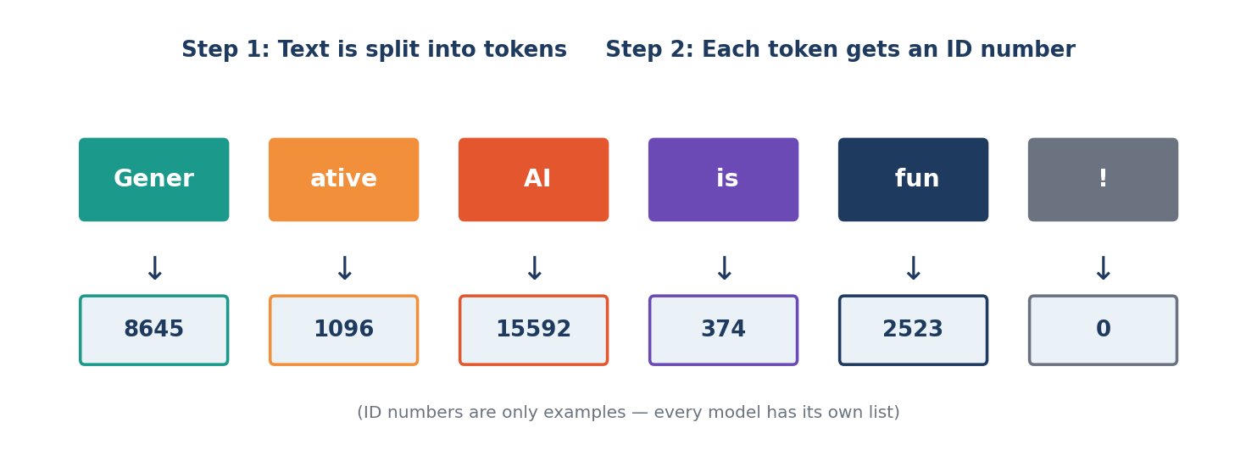
Figure 4.1: Tokenization — the sentence is split into tokens, and every token has an ID number.

Why not use whole words only?
- There are too many words in the world — new words appear every day (names, slang, technical terms).
- Splitting rare words into pieces lets the model handle words it has never seen, such as a new brand name.
- It works for many languages, spelling mistakes and even computer code.
📌 Example
The word “unbelievable” might be split into “un” + “believ” + “able”. The model knows each small piece from many other words (un-happy, believe, capable), so it can understand the new combination.

📏 Rule of thumb
In English, 1 token is roughly ¾ of a word (about 4 characters). So 100 words are about 130 tokens. Other languages, including Tamil, often need more tokens per word, because their words are split into more pieces.

4.3 Embeddings — Giving Meaning to Numbers
Token ID numbers are just labels — like roll numbers. The ID 8645 does not tell us anything about meaning. So the model converts each token into an embedding: a long list of numbers (for example, hundreds or thousands of numbers) that acts like an address on a “map of meaning”.
On this map, words with similar meanings are placed close together, and words with different meanings are far apart. Figure 4.2 shows a simplified 2-D version. Real embeddings have many more dimensions, which we cannot draw.
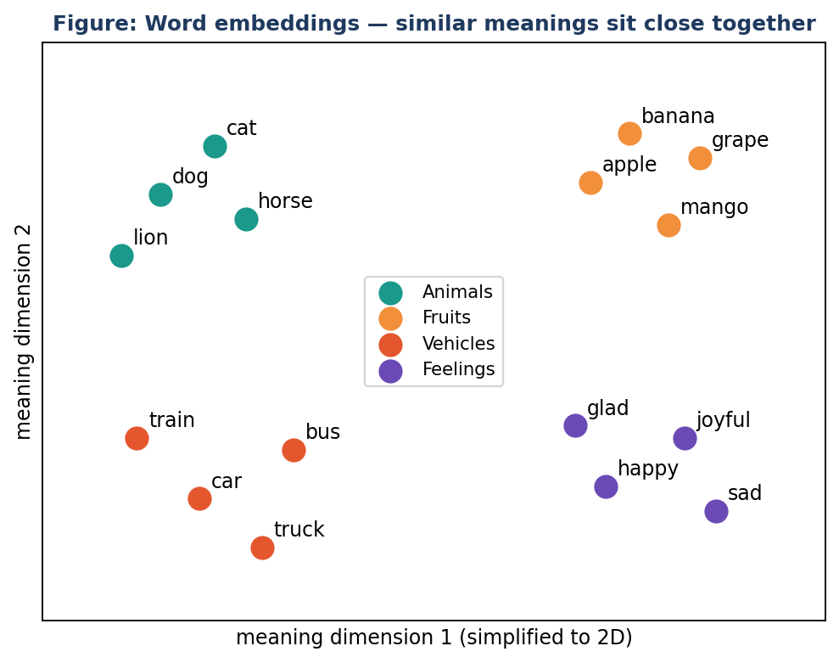
Figure 4.2: Similar words lie close together on the meaning map.

Meaning through relationships
Embeddings capture even relationships. A famous example: if you take the embedding of “king”, subtract “man”, and add “woman”, you land very close to “queen”. The model learned this pattern only by reading text, without anyone teaching it grammar or royalty.
➗ King – Man + Woman ≈ Queen
This shows that directions on the meaning map can represent ideas such as gender or capital city. For instance: Paris – France + India ≈ New Delhi.

4.4 Position Matters Too
“Dog bites man” and “Man bites dog” use the same words but mean different things. So the model also adds position information to each token, telling it whether the token is first, second, third and so on. This is called positional encoding.

4.5 The Complete Journey So Far
Step | What happens | Example
1. Text | You type a sentence | “I love learning AI”
2. Tokens | Text is cut into pieces | [“I”, “ love”, “ learning”, “ AI”]
3. IDs | Each piece gets a number | [40, 3021, 7421, 15592]
4. Embeddings | Each ID becomes a long list of numbers (meaning) | [0.12, –0.8, 0.33, ...]
5. Position | Order information is added | 1st, 2nd, 3rd, 4th

⭐ Key Points to Remember
Computers work with numbers, so text must be converted.
A token is a piece of text; the tokenizer creates tokens.
An embedding is a list of numbers that represents meaning.
Similar words have embeddings that are close together.
Position information tells the model the order of words.

✏️ Activity: Token Split Game
Take the words: playing, unhappiness, teacher, ChatBot, schoolbag.
Try splitting each into 2 or 3 meaningful pieces (for example, play + ing).
Discuss: why does splitting help a model understand new words?

❓ Check Your Understanding
1. What is a token? Give two examples.
2. Why do LLMs use pieces of words instead of whole words?
3. What is an embedding? Explain with the “map of meaning” idea.
4. Why is positional information needed?
5. Complete: King – Man + Woman ≈ ______.

Chapter 5
The Transformer and the Power of Attention
Week 2 • Session 8
🎯 Learning Objectives
After this chapter, you will be able to:
• Explain why older models struggled with long sentences.
• Describe the idea of “attention” in simple words.
• Describe the main parts of a Transformer block.
• Explain what a context window is.

5.1 The Problem with Older Models
Before 2017, language models read text word by word, from left to right, and tried to remember everything in a small “memory”. For long sentences, they often forgot the beginning by the time they reached the end. They were also slow, because they could not read many words at once.
In 2017, a team of researchers published a paper titled “Attention Is All You Need”. It introduced the Transformer, a new design that could look at all the words together and decide which words are important for understanding each other. Almost every modern LLM is based on the Transformer. (The “T” in GPT stands for Transformer.)

5.2 What Is Attention?
Read this sentence: “The animal didn’t cross the street because it was tired.”* What does“it” mean? You know it means the animal, not the street, because animals get tired. Your brain paid attention to the right word.
The Transformer does something similar. For every word, it calculates how much attention to pay to every other word, and uses the important ones to understand the meaning.
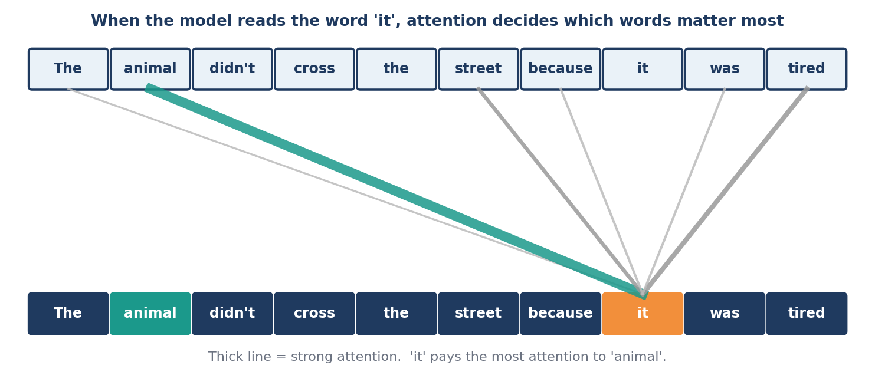
Figure 5.1: When processing “it”, the model gives the most attention to “animal”.
📌 Example
Attention is like highlighting a textbook. When you revise, you do not give equal importance to every word. You highlight the key terms. The attention mechanism “highlights” the most useful words for the current task — and it does this for every word, thousands of times.

Attention in a classroom
Imagine a class where every student is a word. Each student asks, “Who in this class has information that helps me?” (Query). Every student also shows a name tag describing what they know (Key) and holds the actual information (Value). A student listens most to those whose name tag matches the question and collects their information. This Query–Key–Value idea is the heart of self-attention.
Part | Question it answers | Classroom comparison
Query | “What am I looking for?” | A student asking for help
Key | “What do I contain?” | Name tag of each student
Value | “Here is my information.” | What the student actually knows

5.3 Inside a Transformer
A Transformer is built by stacking identical blocks one above the other (dozens of them in a large model). Each block has two main parts:
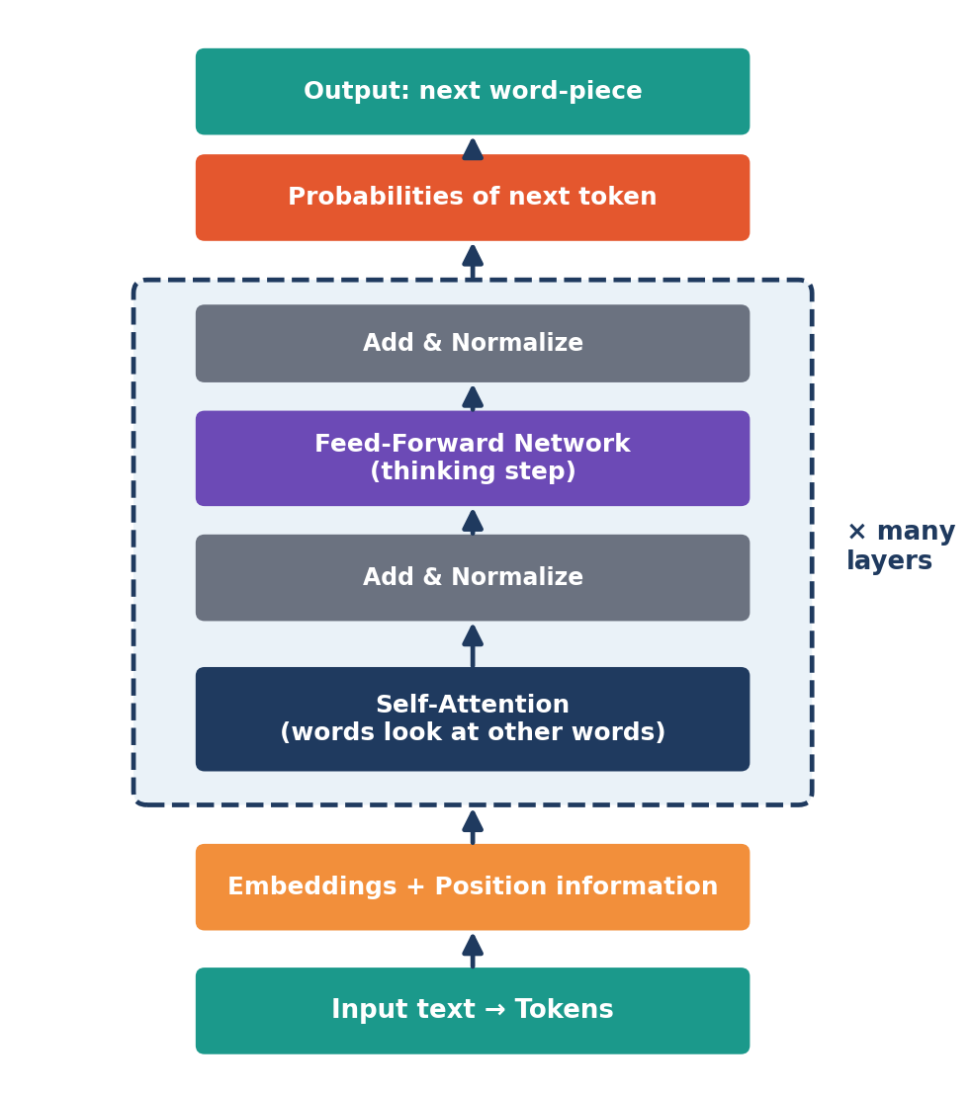
Figure 5.2: The path of data through a Transformer. The dashed box is repeated many times.
- Self-attention — each token collects useful information from the other tokens.
- Feed-forward network — a small neural network that processes the collected information (the “thinking” step).
- Add & Normalise — keeps the numbers stable and helps training.
- Many layers — early layers learn simple things like grammar; later layers learn deeper ideas such as meaning, facts and reasoning.

Multi-head attention
The model does not use only one attention. It uses many — called heads — at the same time. One head may focus on grammar, another on which noun a pronoun refers to, another on topic. It is like a team of readers, each looking for something different, who then combine their notes.

5.4 Why Transformers Changed Everything
Old models | Transformers
Read word by word | Read all words together (parallel)
Forgot long-ago words | Can connect any word to any other word
Slow to train | Fast on modern computer chips
Hard to make very large | Scale well to billions of parameters

5.5 The Context Window
An LLM can only look at a limited amount of text at one time. This limit is called the context window, measured in tokens. It includes your question, the earlier part of the conversation, any documents you pasted and the answer being written.
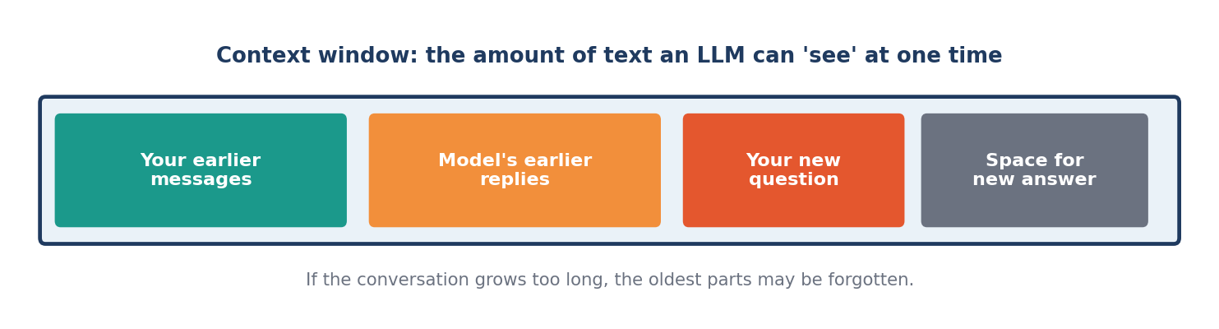
Figure 5.3: Everything the model can “see” must fit inside the context window.
If a conversation becomes longer than the window, the earliest parts may no longer be visible to the model, so it can forget what you said at the start. Newer models have much bigger windows, but the limit still exists. This is also why the model does not remember you from one chat to another unless the app provides a memory feature.
⭐ Key Points to Remember
The Transformer (2017) reads all words together using attention.
Attention decides which words matter most for each word.
A Transformer is a stack of blocks: self-attention + feed-forward network.
Many attention heads look for different kinds of relationships.
The context window is the amount of text the model can see at once.

✏️ Activity: Who Does ‘They’ Mean?
Read: “The teachers told the students that they would get a holiday.”
Who is “they”? Discuss how you decided.
Now change the sentence: “The teachers told the students that they must be quiet.” Does your answer change? This is what attention helps a model do.

❓ Check Your Understanding
1. What was the main problem with older language models?
2. In your own words, what is attention?
3. Name the two main parts of a Transformer block.
4. What is a context window? What happens when it is full?
5. Why are many attention heads used instead of one?

Chapter 6
How an LLM Is Trained
Week 2 • Session 9–10
🎯 Learning Objectives
After this chapter, you will be able to:
• Describe the stages of building an LLM: pre-training, fine-tuning and human feedback.
• Explain what training data is and why its quality matters.
• Understand the basic idea of RLHF.
• Describe the effort and cost involved in building an LLM.

6.1 The Four Stages
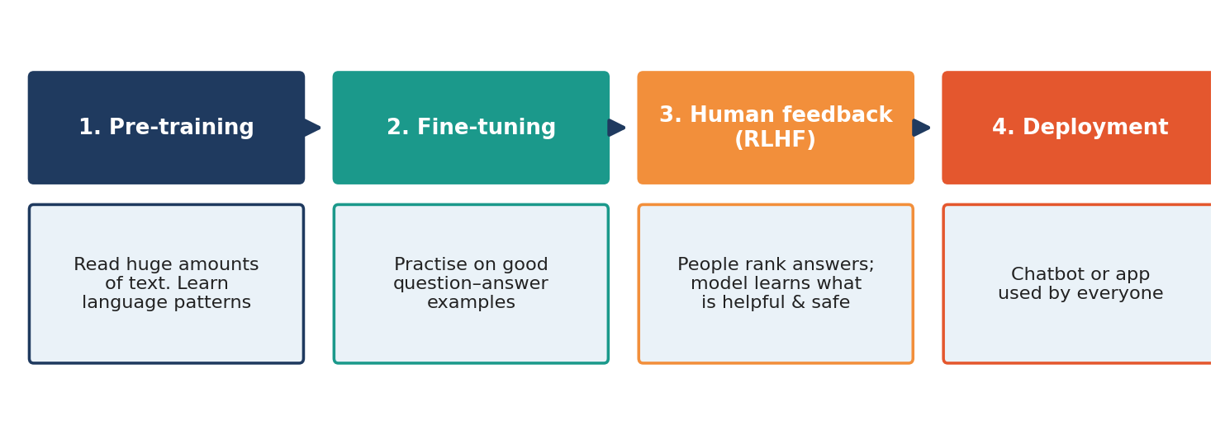
Figure 6.1: From raw text to a helpful chatbot.

6.2 Stage 1 — Pre-training: Learning Language
In pre-training the model reads an enormous collection of text: books, news, encyclopedias, websites, scientific papers and computer code. The task is simple and self-supervised: hide the next token and predict it.
📌 Example
Text: “The Taj Mahal is in ____.” The model guesses “Delhi” at first (wrong). The right answer is “Agra”. The model adjusts its weights slightly so that “Agra” becomes more likely next time. Repeat this trillions of times with different sentences.

By doing this over and over, the model slowly learns grammar, facts, writing styles, common sense and even some reasoning. At the end of pre-training we have a base model. It is very good at continuing text, but it is not yet a polite assistant. Asked “What is the capital of India?”, it might continue with more questions like a quiz, instead of answering.

What data is used?
- Books and articles, encyclopedias and educational content.
- Public websites (after cleaning and filtering).
- Computer programs (code), mathematics and science papers.
- Text in many languages.
🧹 Data quality matters
“Garbage in, garbage out.” Developers remove duplicate pages, spam, harmful content and private information as far as possible. The model learns from what it reads — so if the data has mistakes or unfair opinions, the model can learn them too.

6.3 Stage 2 — Fine-tuning: Learning to Follow Instructions
Next, the base model is trained on a smaller set of high-quality examples of instructions and good answers, many written by people. For example:
Instruction | Good answer (example)
“Summarise this paragraph.” | A short, correct summary
“Translate ‘good morning’ into Hindi.” | “शुभ प्रभात”
“Explain gravity to a child.” | A simple, friendly explanation

After this stage, the model behaves like an assistant: it understands that you are giving it a task and tries to answer in a helpful form. This is called instruction tuning.

6.4 Stage 3 — Learning from Human Feedback (RLHF)
Even a fine-tuned model can give answers that are unhelpful, rude or unsafe. So the developers use Reinforcement Learning from Human Feedback (RLHF):
- The model writes several answers to the same question.
- Human reviewers rank them from best to worst — considering helpfulness, honesty and safety.
- A reward model learns to predict which answers humans prefer.
- The LLM is trained to produce answers that earn higher rewards.
📌 Example
Question: “How can I score well in exams?” Answer A is a rude one-liner. Answer B gives clear, kind, practical tips. Reviewers rank B higher, and the model learns to prefer answers like B.

Developers also write rules and guidelines (sometimes called a constitution or policy) to teach the model to refuse harmful requests and to be honest about what it does not know.

6.5 Stage 4 — Testing and Deployment
Before release, the model is tested extensively on exams, reasoning puzzles, coding tasks and safety checks. Special teams, called red teams, try to make the model fail or misbehave so that problems can be found and fixed. Finally, the model is put inside a chatbot or app so people can use it. Using the trained model to answer questions is called inference.

6.6 The Cost of Building an LLM
Resource | Why it is needed
Data | Huge, cleaned collections of text and code
Computing chips | Thousands of special chips (GPUs/TPUs) working together
Electricity | Training and running models use a lot of energy
Money | Training a top model can cost tens or hundreds of millions of dollars
People | Researchers, engineers, data experts, reviewers and safety teams

💡 Did You Know?
Training a large model is like building a giant library, hiring thousands of teachers to check it, and running a factory day and night — all before the first student asks a question!

⭐ Key Points to Remember
Pre-training teaches language by predicting the next token on huge data.
Fine-tuning teaches the model to follow instructions.
RLHF uses human rankings to make answers helpful, honest and safe.
The quality of training data strongly affects the quality of the model.
Using a trained model to answer is called inference.

✏️ Activity: Rank the Answers
Ask a classmate: “Explain why we have day and night.” Prepare three different answers (one wrong, one boring, one clear and friendly).
Let five students rank the answers from best to worst.
Compare the rankings. This is a mini version of human feedback.

❓ Check Your Understanding
1. List the four stages of building a chatbot-style LLM.
2. What is the training task in pre-training?
3. Why is fine-tuning needed after pre-training?
4. Expand RLHF and explain it in three or four lines.
5. Why is data quality important?

Chapter 7
How an LLM Writes — Generating Text
Week 3 • Session 11
🎯 Learning Objectives
After this chapter, you will be able to:
• Explain how an LLM produces an answer one token at a time.
• Understand probabilities of next words.
• Explain what “temperature” does.
• Understand why the same question can give different answers.

7.1 Predicting the Next Token
After the Transformer processes your prompt, the last step is to produce a list of probabilities — one for every token in the model’s vocabulary (often 50,000 to 200,000 tokens). The probability tells us how likely each token is to come next.
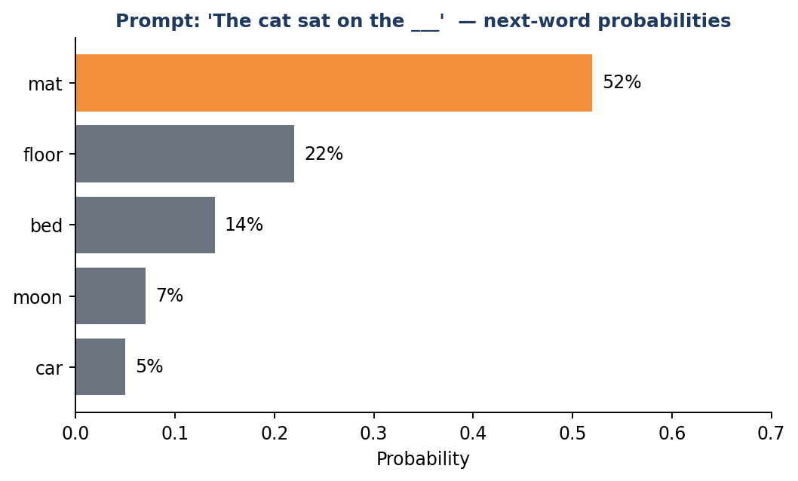
Figure 7.1: For “The cat sat on the ___”, the model gives the highest probability to “mat”.
Notice that the model does not just know one correct answer. It knows that “mat” is very likely, “floor” is possible, and “moon” is unlikely but not impossible. This list of chances is the true output of an LLM.

7.2 One Token at a Time — Autoregressive Generation
The model chooses a token, adds it to the text, and then uses the longer text to predict the next token. This loop continues until the answer is complete. Because each new token depends on the earlier ones, this is called autoregressive generation.
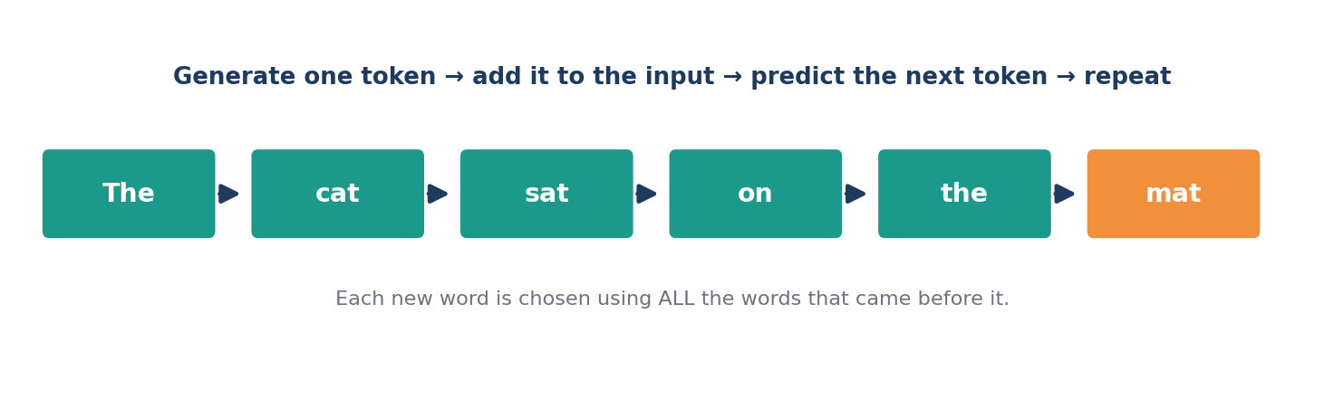
Figure 7.2: The generation loop — predict, add, repeat.
📌 Example
Chain story game. In a group, one student says a word, the next adds another word, and so on, and the story grows. Each person must use all the words said earlier. An LLM plays the same game with itself.

7.3 Choosing the Token — Sampling
How does the model pick from the list? There are two simple methods:
Method | What it does | Result
Greedy | Always choose the token with the highest probability | Safe and repeatable, but can be dull
Sampling | Pick randomly, but more probable tokens are more likely to be chosen | More variety and creativity

That is why you can ask the same question twice and receive two different answers. The model is not being inconsistent; it is sampling from probabilities.

7.4 Temperature — The Creativity Dial
Temperature is a setting that controls how adventurous the sampling is.
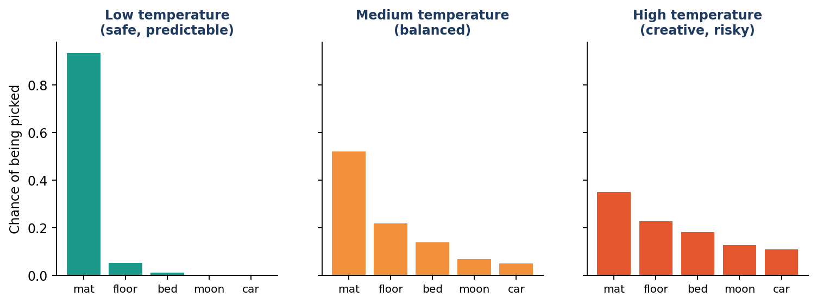
Figure 7.3: Low temperature favours the top choice. High temperature gives other words a better chance.
Temperature | Behaviour | Best used for
Low (close to 0) | Very focused, predictable, factual | Maths, facts, code, summaries
Medium | Balanced | General conversations
High | Varied, imaginative, but more mistakes | Poems, stories, brainstorming

Other settings you may meet are top-p and top-k. They limit the choice to only the most likely tokens, so that the model avoids very strange words. Also, a maximum length setting stops the model after a given number of tokens.

7.5 Why Does the Answer Look So Fluent?
Because the model has seen so many examples of good writing, the words it chooses usually fit together smoothly. But fluent does not mean correct. The model is optimised to produce text that sounds natural and likely — and sometimes the most natural-sounding sentence is not the true one. We study this problem in Chapter 9.

7.6 Reasoning Step by Step
For difficult problems, such as maths, models give better results when they write out their steps before the final answer — just like you do in an exam. Because each step becomes part of the text the model can read, it helps the model reach the answer more reliably. Some newer models are trained to “think” through a problem at length before replying. You can also help by adding “Let’s solve this step by step” to your prompt.
⭐ Key Points to Remember
The model outputs probabilities for the next token and picks one.
Generation is a loop: predict → add → repeat (autoregressive).
Sampling makes answers different each time.
Temperature controls creativity: low = safe, high = creative.
Writing steps helps the model solve harder problems.

✏️ Activity: Temperature Test
Open any AI chatbot (with your teacher’s permission) and ask: “Write a one-line slogan for a school library.” Ask the same question three times.
Notice how the answers vary. Then ask for “a very creative” and “a very formal” version.
Write a paragraph on what you observed.

❓ Check Your Understanding
1. What does an LLM actually output at each step?
2. What does “autoregressive” mean?
3. Why might an LLM give different answers to the same question?
4. When would you choose a low temperature? When a high one?
5. Why does asking for steps often improve answers to maths problems?

Chapter 8
Talking to AI — The Art of Prompting
Week 3 • Sessions 12–13
🎯 Learning Objectives
After this chapter, you will be able to:
• Define a prompt and prompt engineering.
• Write clear prompts using Role, Task, Context and Format.
• Use techniques such as examples, step-by-step thinking and iteration.
• Avoid common prompting mistakes.

8.1 What Is a Prompt?
A prompt is the instruction or question you give to an AI model. Prompt engineering is the skill of writing prompts that help the model give the best possible answer. Since an LLM predicts text based on what you give it, better input leads to better output.
📌 Example
Weak prompt: “Tell me about photosynthesis.”
Better prompt: “Explain photosynthesis to a Class 7 student in 6 simple lines, with one everyday example and the chemical equation at the end.”

8.2 The Four Parts of a Good Prompt
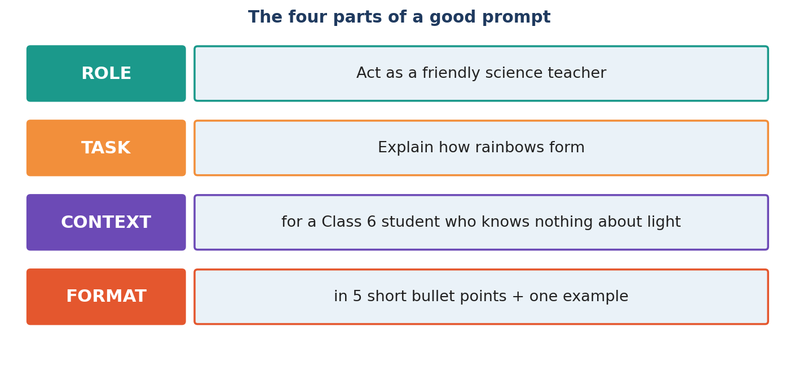
Figure 8.1: Role, Task, Context and Format.
Part | Meaning | Example
Role | Who the AI should act as | “You are a patient maths teacher.”
Task | What exactly you want done | “Explain the Pythagoras theorem.”
Context | Background: audience, level, purpose | “For a student who finds geometry difficult.”
Format | How the answer should look | “Use 4 steps and one worked example.”

8.3 Useful Prompting Techniques

1. Be specific
Say what you want, how long it should be, who it is for and in which language. “Write a 100-word paragraph in simple English about the Indian Space Research Organisation” is better than “Write about space”.

2. Give examples (few-shot prompting)
Show the model one or two examples of what you want. It will copy the pattern.
📌 Example
Convert words to their opposites.
hot → cold
tall → short
happy → ? (The model replies: sad)

3. Ask for step-by-step thinking
For problems, add: “Think step by step and show your working.” This often reduces mistakes.

4. Break big tasks into small steps
Instead of “Write my full project”, ask first for an outline, then each section, then improvements.

5. Iterate — improve with follow-up prompts
Your first prompt need not be perfect. Reply with “Make it shorter”, “Use simpler words”, “Add one more example” or “Explain the second point again”. Good prompting is a conversation.

6. Set limits and style
Tell the model the tone (friendly, formal), the length, and what to avoid. Example: “Do not use technical words.”

8.4 Good and Bad Prompts
Poor prompt | Improved prompt
“Write an essay.” | “Write a 250-word essay on ‘Importance of Sleep for Students’ for a school magazine, in simple English, with an introduction, 3 points and a conclusion.”
“Solve this.” | “Solve this quadratic equation step by step and explain each step: x² – 5x + 6 = 0.”
“Give notes.” | “Make revision notes of Chapter 5 ‘Light’ for Class 10 in bullet points with 5 key terms and a 3-question quiz.”

8.5 Using AI as a Study Partner — The Right Way
- Ask it to explain a concept in different ways until you understand.
- Ask it to quiz you and then check your answers.
- Ask for feedback on your own writing — not for writing it for you.
- Ask “What mistakes do students usually make in this topic?”
- Always verify important facts from your textbook or teacher.
⚠️ Be careful with personal information
Never type your full name, address, phone number, passwords, bank details or private photos of yourself or others into a chatbot. Treat it like a public place.

⭐ Key Points to Remember
A prompt is your instruction; better prompts give better answers.
Use Role + Task + Context + Format.
Techniques: be specific, give examples, think step by step, break tasks down, iterate.
Never share private information with AI tools.
Use AI to learn, not to avoid learning.

✏️ Activity: Prompt Makeover
Take the weak prompt: “Tell me about the Moon.”
Rewrite it using Role, Task, Context and Format. Try it and note the answer.
Swap prompts with a friend. Improve each other’s prompt using one new technique.

❓ Check Your Understanding
1. What is prompt engineering?
2. Write the four parts of a good prompt with one example for each.
3. What is few-shot prompting?
4. Rewrite “Write about India” as a strong prompt.
5. Name two kinds of information you should never share with a chatbot.

Chapter 9
Limits and Risks of LLMs
Week 3 • Session 14
🎯 Learning Objectives
After this chapter, you will be able to:
• Explain hallucination and why it happens.
• Describe bias in AI and where it comes from.
• List the main limitations of LLMs.
• Explain how methods such as RAG and fact-checking help.

9.1 LLMs Make Mistakes
LLMs are impressive, but they are not perfect. Because they work by predicting likely text, they can produce answers that sound confident yet are wrong. A responsible user must know these limits.

9.2 Hallucination
A hallucination happens when an AI produces information that is false or made up, but presents it as if it were true. For example, it may invent a book title, a historical date, a scientific study or a web link that does not exist.

Why does it happen?
- The model is built to produce likely-sounding text, not to check truth.
- If it did not learn a fact properly, it may still “fill the gap” with something that fits the pattern.
- Its knowledge may be old or incomplete.
- An unclear question can push it toward guessing.
📌 Example
Ask: “Who won the school science quiz in 2031 at Anand Public School?” A model with no such information should say it does not know — but sometimes it invents a name. That is a hallucination.

How to reduce its effect
- Ask the model to say “I don’t know” when it is unsure.
- Ask for sources — and then actually check that the sources exist.
- Cross-check important facts with textbooks and trusted websites.
- Give the model the correct text and ask it to answer only from that text.

9.3 Giving the Model Facts — RAG
Retrieval-Augmented Generation (RAG) is a method where, before answering, the system first searches a trusted collection of documents (for example, your school’s textbook or a company’s rules), then gives the found facts to the LLM along with your question. The LLM writes the answer using those facts.
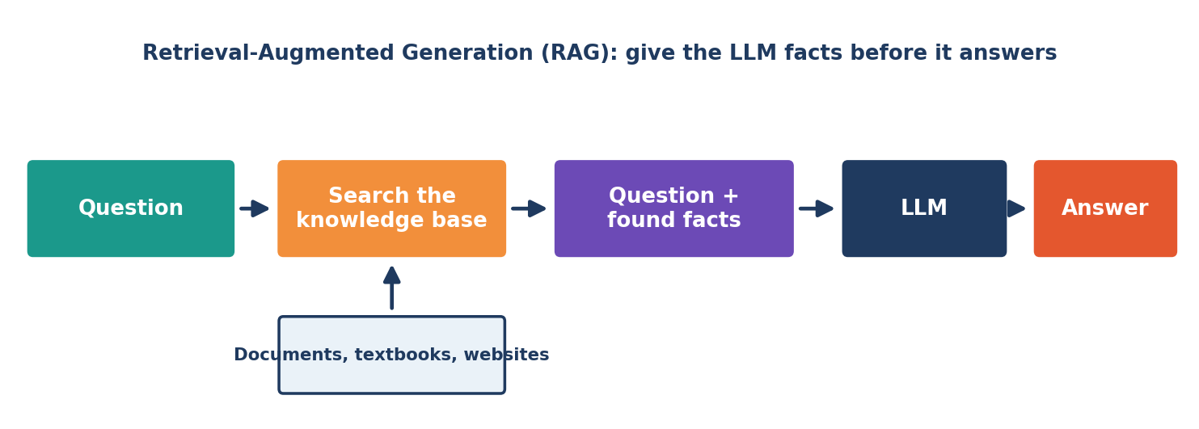
Figure 9.1: RAG — search first, then answer.
RAG makes answers more accurate and up to date, and lets the model use information it was never trained on. It is like an open-book exam: the student (LLM) can look at the book before writing the answer.

9.4 Bias
Bias means unfair leaning towards or against certain people or ideas. Since LLMs learn from human writing, they can pick up the stereotypes and unfair views that exist in that writing. For example, a model might unfairly connect certain jobs with one gender, or give less accurate answers about some languages, regions or communities because there was less data about them.
Source of bias | Explanation
Training data | The internet over-represents some groups and under-represents others
Human reviewers | Reviewers have their own viewpoints and backgrounds
Design choices | What developers decide to measure and improve

Developers try to reduce bias by improving data, testing models on many groups and adding safety training — but it cannot be fully removed. You must think critically about what the AI tells you.

9.5 Other Limitations
Limitation | What it means
Knowledge cut-off | The model only knows things up to its training date, unless connected to search
Limited memory | It can only see what fits in the context window
Weak at some maths/logic | It can slip on long calculations unless it uses tools or works step by step
No real experience | It has never seen, felt or done anything in the real world
Sensitive to wording | A small change in the prompt can change the answer
Cost and energy | Running big models needs a lot of computing power and electricity

9.6 The SAFE Checklist for Using AI Answers
Letter | Check | Question to ask yourself
S | Source | Did the AI give a source? Does it really exist?
A | Accuracy | Does this match my textbook or a trusted website?
F | Fairness | Is the answer fair, or does it show stereotypes?
E | Ethics | Am I using this honestly, without copying or cheating?

⭐ Key Points to Remember
Hallucination = confident but false or invented information.
RAG gives the model trusted facts before it answers.
Bias comes from the data and humans behind the model.
Always check important information using the SAFE checklist.

✏️ Activity: Hallucination Hunt
With your teacher, ask an AI tool five factual questions to which you already know the answers (e.g., from your textbook).
Mark each answer ✔ correct, ✖ wrong, or ? partly correct.
Discuss what kinds of questions the AI got wrong.

❓ Check Your Understanding
1. What is a hallucination? Give an example.
2. Explain RAG with the open-book exam comparison.
3. How can bias enter an AI model?
4. Write any three limitations of LLMs.
5. What do the letters S-A-F-E stand for in our checklist?

Chapter 10
Beyond Text — Images, Audio and Video
Week 3 • Session 15
🎯 Learning Objectives
After this chapter, you will be able to:
• Explain how Generative AI can create images, audio and video.
• Describe the basic idea of diffusion models and GANs.
• Explain what a multimodal model is.
• Understand why AI-made media can be misused.

10.1 Generative AI Is Not Only About Text
The same big idea — learn patterns from huge amounts of data and then create something new — also works for pictures, sounds and videos. Text is simply one kind of data. Images are made of pixels, sound is made of waves, and video is a sequence of images — all of which can be turned into numbers and learned by neural networks.

10.2 Diffusion Models — Creating Images from Noise
Most popular image generators use diffusion models. Their training and working has two parts:
- Training: Take a real picture and slowly add random “noise” (like TV static) until nothing can be seen. Teach the model to reverse this — to remove a little noise at a time.
- Generating: Start with pure noise. Guided by your text description, the model removes noise step by step until a new picture appears.
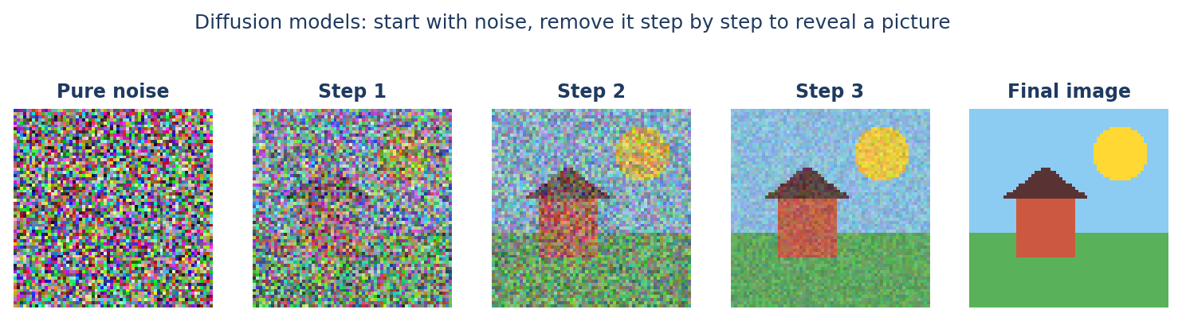
Figure 10.1: A diffusion model turns random noise into a picture, step by step.
📌 Example
A sculptor and a block of stone. The sculptor starts with a rough block and removes tiny bits again and again until a statue is revealed. A diffusion model starts with a block of “noise” and removes noise until a picture is revealed — guided by your words.

To connect words with pictures, the system uses a model trained on millions of image–caption pairs, so it knows that the words “a red kite in a blue sky” relate to certain shapes and colours.

10.3 GANs — The Artist and the Detective
A Generative Adversarial Network (GAN) has two neural networks that compete:
- The Generator is like a forger — it tries to create fake images that look real.
- The Discriminator is like a detective — it tries to tell real images from fake ones.
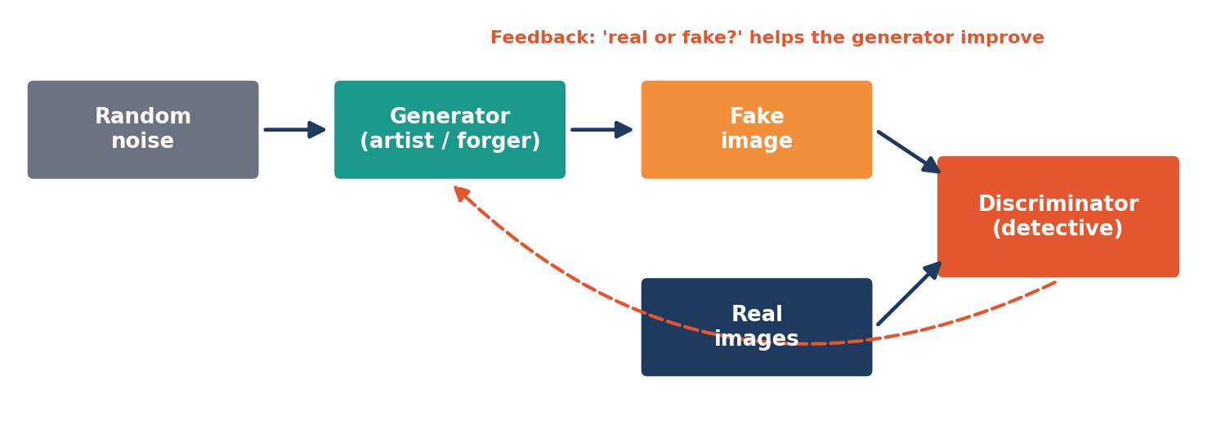
Figure 10.2: In a GAN, the generator and discriminator improve by competing.
Each time the detective catches a fake, the forger learns to do better. After a long competition, the forger becomes so skilled that its images look real. GANs were important in early AI art, face generation and photo editing.

10.4 Audio, Music and Video
Type | What AI can do | How it works (simple idea)
Speech | Read text aloud in natural voices; turn speech into text | Learns patterns of sound waves linked with words
Music | Create tunes in a chosen mood or style | Learns patterns of notes, rhythm and instruments
Video | Create short clips from a description | Extends image generation across many frames, keeping motion smooth
3D | Create 3D shapes and scenes | Learns shapes and depth from many examples

10.5 Multimodal Models
A multimodal model can work with more than one kind of data — for example, understand a photograph and answer questions about it, read a chart, listen to speech and reply in text. Everything is changed into numbers (embeddings) so the same Transformer can process them together.
📌 Example
Show a picture of your science experiment and ask: “What mistake is in this setup?” The model reads the image and replies in words.

10.6 Deepfakes and Misuse
The same tools can be misused to make deepfakes — fake photos, voices or videos that look real. They can be used to spread false news, cheat people or harm someone’s reputation. Creating or sharing harmful fake media is unethical and may be a punishable offence.
🔍 How to spot possible AI-made media
• Look for strange details — odd fingers, blurry text, uneven shadows.
• Check who first shared it and whether trusted news sources report the same thing.
• Pause before sharing. If you are not sure, do not forward it.

⭐ Key Points to Remember
Generative AI can create images, audio, music and video, not only text.
Diffusion models turn noise into pictures step by step.
GANs use a generator and a discriminator that compete.
Multimodal models handle text, images and sound together.
Deepfakes are fake media — never create or share them to harm others.

✏️ Activity: Describe-to-Draw
Write a detailed description (4 lines) of a scene. Give it to a classmate who draws what he/she imagines.
Compare the drawing with your idea. What details were missing? This shows why detailed prompts matter for image generators.

❓ Check Your Understanding
1. Explain the diffusion process using the sculptor example.
2. What are the two parts of a GAN? What does each do?
3. What is a multimodal model? Give an example.
4. What is a deepfake? Why is it dangerous?
5. Name two ways to check whether an image is trustworthy.

Chapter 11
Using AI Responsibly — Ethics and Safety
Week 4 • Session 16
🎯 Learning Objectives
After this chapter, you will be able to:
• Explain why ethics matters in AI.
• Discuss privacy, copyright, fairness and honesty issues.
• Follow rules for responsible AI use in school.
• Understand the idea of safe and trustworthy AI.

11.1 Why Ethics Matters
Ethics means knowing what is right and wrong. AI is a powerful tool: it can help millions of people learn, work and create — but it can also cause harm if used carelessly. As future citizens, you will decide how AI is used in society, so you must understand its responsibilities.

11.2 Key Ethical Issues
Issue | What it means | What you can do
Privacy | AI tools may store what you type. Private data can be misused. | Never share personal details, passwords, or others’ private information.
Fairness / Bias | AI can treat some groups unfairly. | Question stereotypes; report unfair answers.
Honesty | Passing off AI work as your own is cheating. | Declare when you used AI; do your own thinking.
Copyright | AI is trained on works of many creators; its output may resemble existing work. | Respect creators; do not copy and claim ownership; give credit.
Misinformation | AI can produce false content that spreads fast. | Verify before sharing.
Safety | AI could give harmful advice or be used for harmful purposes. | Do not misuse AI; seek trusted adults for serious matters like health.
Environment | Training and running models uses much energy. | Use AI thoughtfully, not wastefully.

11.3 Academic Honesty — A Student’s Code
- Allowed (with permission): asking AI to explain a topic, quiz you, suggest ideas, check grammar, or give feedback.
- Not allowed: submitting AI-written assignments as your own, using AI in exams without permission, or inventing data or sources.
- Always: follow your school’s rules and mention AI help when asked.
🧭 The ‘Would I be proud?’ test
Before using AI for any task, ask yourself: Am I learning from this? Would I be comfortable showing my teacher exactly how I used it? If the answer is no, do not do it.

11.4 Human in the Loop
For important decisions — such as health, law, money, or a student’s marks — AI should assist, not replace, human judgement. Keeping a human in the loop means a person reviews and takes responsibility for the final decision. AI can suggest; humans must decide.

11.5 Principles of Trustworthy AI
Principle | Meaning
Fairness | Treats all people equally and without discrimination
Transparency | People should know when AI is used and how it reaches results
Privacy | Protects personal data
Safety & reliability | Works properly and does not cause harm
Accountability | Someone is responsible for what AI does
Human benefit | Designed to help people and society

⭐ Key Points to Remember
Be honest, fair, private and safe when using AI.
Never share personal information with chatbots.
Do not present AI work as your own; follow school rules.
Keep a human in the loop for important decisions.
Do not create or share harmful or fake content.

✏️ Activity: Class Debate
Topic: “Students should be allowed to use AI for homework.”
One group argues FOR and the other AGAINST. Then both groups write a set of fair rules that everyone can accept.

❓ Check Your Understanding
1. What is meant by ‘human in the loop’?
2. Give three examples of ethical issues in AI and one solution for each.
3. When is using AI for schoolwork allowed and when is it cheating?
4. Why should you not share personal information with a chatbot?
5. Write any four principles of trustworthy AI.

Chapter 12
Applications, Careers and the Future
Week 4 • Session 17
🎯 Learning Objectives
After this chapter, you will be able to:
• Describe how Generative AI is used in different fields.
• Identify career opportunities connected with AI.
• Explain which skills will be useful in an AI-powered future.
• Think about the future of AI with a balanced view.

12.1 Applications in Different Fields
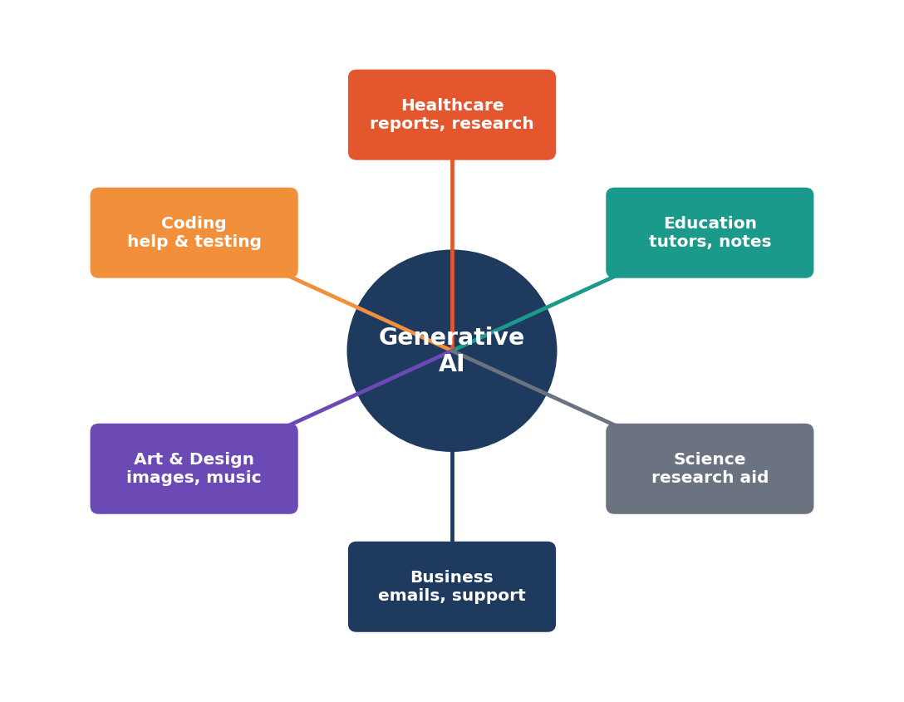
Figure 12.1: Generative AI is used in many fields.
Field | How Generative AI helps
Education | Personal tutors, simple explanations, practice questions, language learning
Healthcare | Drafting reports, summarising research, helping doctors with paperwork (always checked by experts)
Business | Writing emails, customer support, summarising meetings, preparing reports
Software | Suggesting code, finding bugs, writing tests and documentation
Arts & media | Idea generation, design drafts, music and video creation
Science | Reading many research papers quickly, suggesting hypotheses, analysing data
Agriculture | Answering farmers’ questions in local languages, summarising weather and crop advice
Government & society | Translating documents, making services available in many languages

12.2 AI Agents and Tools
Modern LLMs can also be connected to tools — such as web search, a calculator, a calendar or a code editor. When an LLM can plan steps and use tools to complete a task by itself (for example, “find three train options and make a table”), it is often called an AI agent. This makes AI more useful, but also means we must be careful about what permissions we give it.

12.3 Will AI Take Away Jobs?
History shows that new technology changes jobs. Computers ended some jobs, but created many new ones. In the same way, AI will automate some tasks, change many jobs and create new roles. Most experts believe that people who know how to use AI well will have an advantage over those who do not.
Likely to change | New roles appearing
Routine writing, data entry, simple customer replies | Prompt designers and AI trainers
Basic translation and summarising | AI ethics and safety specialists
Repetitive coding tasks | Machine learning engineers, data scientists
Simple image or layout work | AI product managers and AI-assisted creative designers

12.4 Careers You Can Prepare For
- Data scientist / ML engineer — builds and improves AI models.
- AI researcher — discovers new methods.
- Software developer — builds apps using AI.
- Data analyst — finds meaning in data.
- AI ethics and policy expert — makes sure AI is fair and safe.
- Domain experts using AI — doctors, teachers, lawyers, farmers, designers and entrepreneurs who use AI in their own field.
- Educators — teaching others to use AI wisely.

12.5 Skills for the AI Age
Skill | Why it is important
Critical thinking | To judge whether an AI answer is correct and fair
Communication | Clear writing leads to clear prompts
Creativity | AI helps with ideas; humans choose and shape them
Basic maths and programming | To understand how AI works and to build with it
Subject knowledge | You can only check an AI if you know the subject yourself
Ethics and empathy | Humans understand feelings and values
Lifelong learning | Technology keeps changing

12.6 Looking Ahead
Researchers are working to make models more accurate, more efficient and safer, to make them work well in all Indian languages, and to help them handle text, images, audio and video together. We may see smaller models on phones, personal tutors for every child, and tools that help scientists find new medicines. At the same time, society must create good rules, protect privacy, and make sure that the benefits reach everyone.
🌟 A balanced view
AI is neither magic nor a monster. It is a powerful tool created by people. The future depends on how wisely we build and use it — and you are part of that future.

⭐ Key Points to Remember
Generative AI is used in education, health, business, software, arts, science and more.
AI agents combine LLMs with tools to complete tasks.
AI will change jobs and create new ones; learning to use AI well gives an advantage.
Critical thinking, creativity and ethics remain very human strengths.

✏️ Activity: My Future Career Map
Choose a career you are interested in.
Write down 3 ways AI may change that job and 3 skills you will need.
Present your map to the class in 2 minutes.

❓ Check Your Understanding
1. List four fields where Generative AI is used, with one use each.
2. What is an AI agent?
3. Explain how AI may change jobs in the future.
4. Write any five skills useful in an AI world.
5. Why does subject knowledge remain important even when AI tools are available?

Chapter 13
Mini Project, Revision Quiz and Glossary
Week 4 • Sessions 18–20

13.1 Mini Project
In the final week, each student (or a pair) completes one project and presents it in 3–5 minutes. Choose from the ideas below, or propose your own with the teacher’s approval.
No. | Project idea | What to submit
1 | “LLM Explained to a Child” — a poster or comic explaining tokens, embeddings and attention | Chart paper / digital poster + 2-minute talk
2 | Prompt Lab — test 10 prompts (weak vs improved) on an AI tool and compare results | Report with screenshots and conclusions
3 | Hallucination Report — test an AI on 15 textbook facts and record accuracy | Table of results + analysis
4 | AI Ethics Handbook for our School — rules for safe, honest AI use | A 2-page guide
5 | Study Helper — create a set of useful prompts for your favourite subject | Prompt booklet + examples
6 | Future of AI in My Village / Town — how AI can help local people | Presentation

13.2 Project Marking Scheme (20 marks)
Criteria | Marks
Understanding of concepts (accuracy) | 6
Creativity and presentation | 4
Use of diagrams / examples | 3
Responsible use of AI and honesty (mention of how AI was used) | 4
Communication / viva answers | 3

13.3 Revision Quiz
Part A — Choose the correct answer.
- Which of these is the biggest circle in the AI family? (a) Deep Learning (b) Artificial Intelligence (c) Generative AI (d) Machine Learning
- The basic task an LLM learns during pre-training is: (a) drawing pictures (b) predicting the next token (c) playing chess (d) translating only
- A small piece of text with an ID number is called a: (a) token (b) pixel (c) weight (d) prompt
- Which mechanism lets the model decide which words are most important for each word? (a) Backup (b) Attention (c) Compression (d) Sorting
- What does the “T” in GPT stand for? (a) Text (b) Tool (c) Transformer (d) Training
- RLHF stands for: (a) Real Learning for Human Fun (b) Reinforcement Learning from Human Feedback (c) Random Language Handling Format (d) None of these
- A confident but false answer by an AI is called a: (a) prompt (b) hallucination (c) token (d) parameter
- A low temperature setting makes the model: (a) more random (b) more predictable (c) stop working (d) draw images
- Image generators that start with noise and remove it step by step are called: (a) diffusion models (b) token models (c) rule models (d) search engines
- RAG helps an LLM by: (a) giving it facts to read before answering (b) deleting its memory (c) increasing temperature (d) changing its name
Part B — Fill in the blanks.
- Using a trained model to produce answers is called ________.
- The maximum amount of text a model can see at one time is its ________ window.
- In a GAN, the ________ tries to tell real images from fake ones.
- Embeddings place words with similar meaning ________ to each other.
- The four parts of a good prompt are Role, Task, Context and ________.
Part C — Short answers (write 3–5 lines).
- Differentiate between Machine Learning and Generative AI.
- Explain tokenization with an example.
- What is attention? Explain with the sentence about the animal and the street.
- Describe the three stages of training an LLM.
- Why can an LLM give different answers to the same question?
- Explain any three ethical issues related to AI.
Part D — Long answers (write about 10 lines).
- Explain, with a neat diagram, how a Large Language Model generates an answer, starting from your prompt.
- Discuss the limitations of LLMs and explain how a student can use AI safely and honestly.

Answer key — Part A and Part B
Part A | Answer | Part B | Answer
1 | (b) | 1 | inference
2 | (b) | 2 | context
3 | (a) | 3 | discriminator
4 | (b) | 4 | close (near)
5 | (c) | 5 | Format
6 | (b)
7 | (b)
8 | (b)
9 | (a)
10 | (a)

13.4 Glossary
Term | Simple meaning
Artificial Intelligence | Machines doing tasks that normally need human intelligence
Attention | Method that lets a model focus on the most important words
Bias | Unfair leaning towards or against some people or ideas
Context window | The amount of text a model can see at one time
Deep learning | Machine learning using neural networks with many layers
Deepfake | Fake image, audio or video that looks or sounds real
Diffusion model | Image generator that removes noise step by step
Embedding | A list of numbers that represents the meaning of a token
Fine-tuning | Extra training on selected examples to teach a specific skill
GAN | Two networks (generator and discriminator) that compete to improve
Generative AI | AI that creates new content
Hallucination | False or invented information given confidently by AI
Inference | Using a trained model to give answers
LLM | Large Language Model — a huge neural network trained on text
Machine learning | Computers learning patterns from data
Multimodal | Able to handle text, images, audio, etc. together
Neural network | Layers of connected units (neurons) that learn patterns
Parameter / weight | An adjustable number inside a model
Pre-training | First, large-scale training to learn language by predicting tokens
Prompt | The instruction or question given to an AI
RAG | Retrieval-Augmented Generation — search first, then answer
RLHF | Learning from human rankings of answers
Temperature | Setting that controls the creativity of generated text
Token | A small piece of text (word, part of word, or symbol)
Transformer | The neural network design (2017) behind modern LLMs

13.5 Final Words
Generative AI is one of the most exciting technologies of your time. By understanding how Large Language Models work — from tokens and embeddings to attention and training — you are no longer just a user of AI; you are an informed citizen who can question it, guide it and use it for good. Keep curious, keep learning, and always keep your own thinking at the centre.
📚 Suggestions for further learning
• Try a beginner course on Python and Machine Learning.
• Read about how AI is used in your favourite field.
• Practise writing prompts every day and reflect on what works.
• Follow reliable news on AI, and always check facts.

